Lab 9 – My Solutions
2.1: Order of Policy Application. Resolving Conflicts:
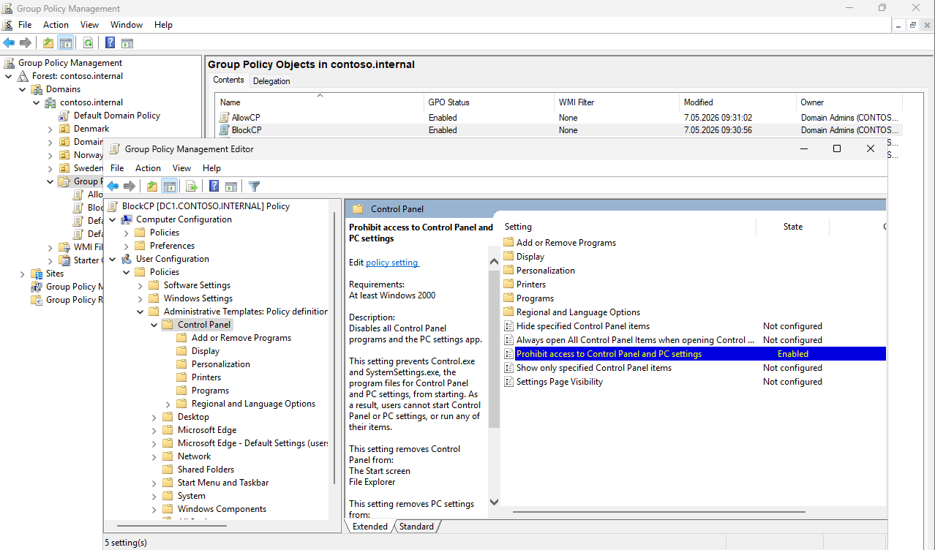
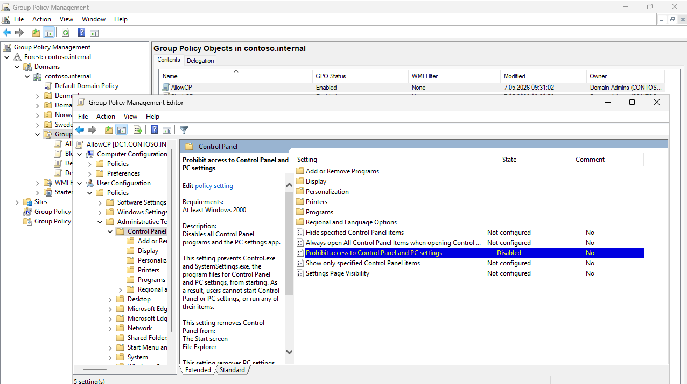
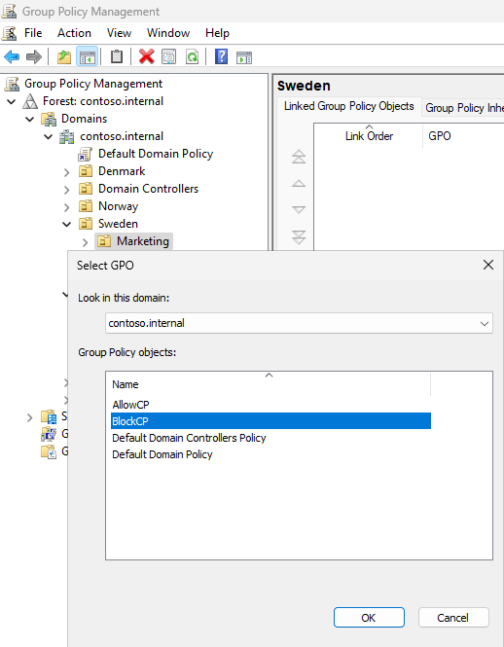
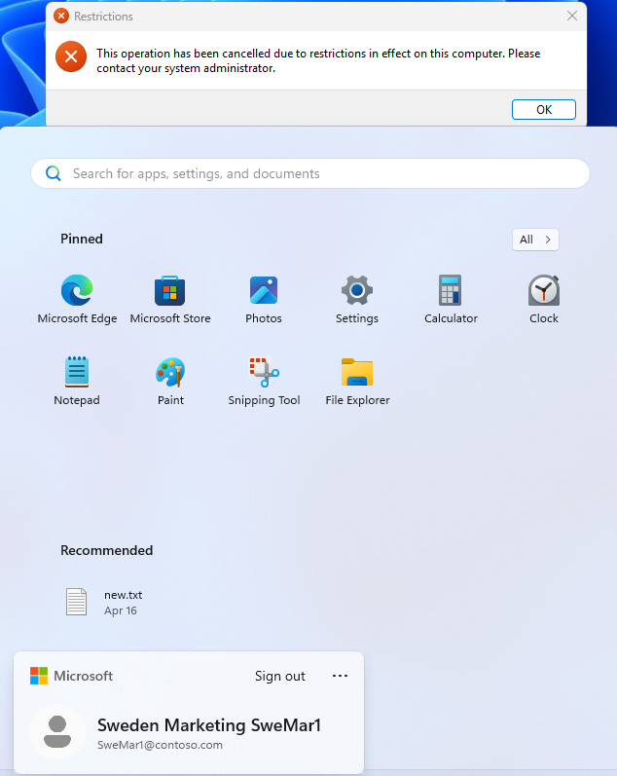
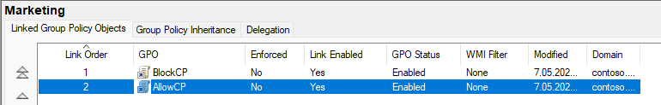


2.2: Inheritance of Policies:


2.2.3
2.2.4

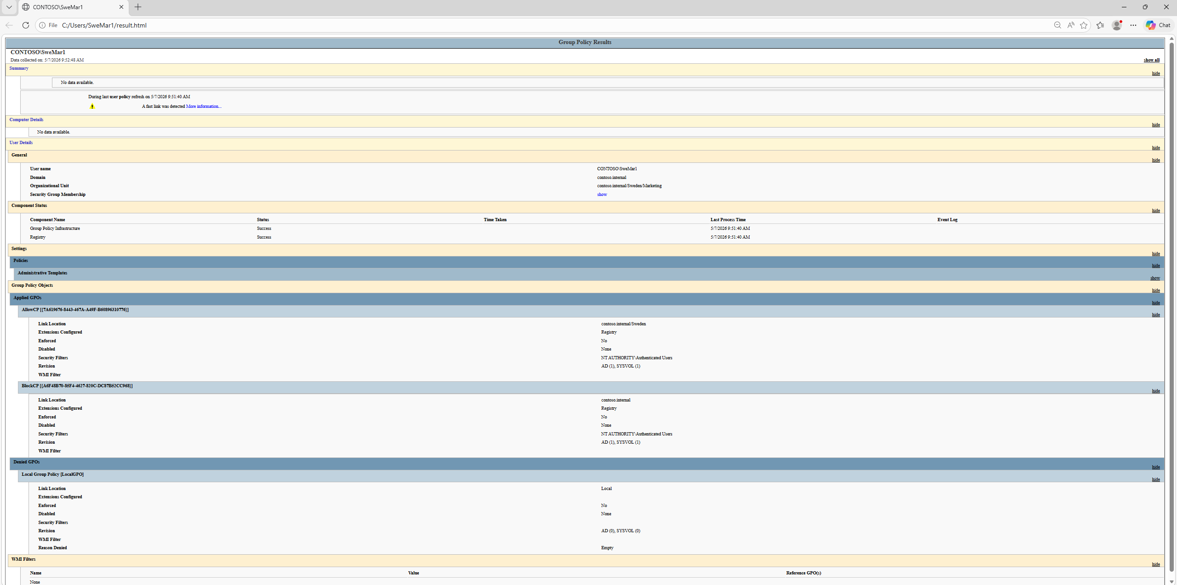
2.2.7
GPOs are processed from the highest (domain) level down to the lowest (closest OU).
The closest OU's GPO takes the highest priority - it overrides parent settings. In this case, BlockCP linked at Sweden/Marketing wins over AllowCP linked at Sweden.

2.3: Controlling Inheritance:
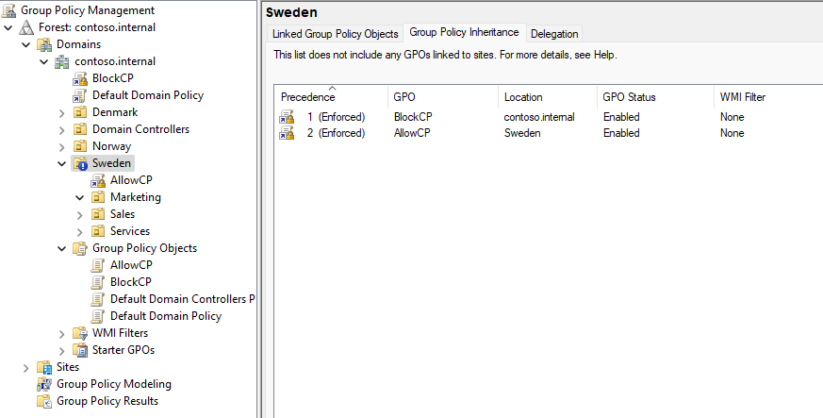
2.3.7
Normal inheritance: child OUs can override parent OU settings (closer = higher priority).
Enforced: the parent GPO setting cannot be overridden by child OUs, and it penetrates even through "Block Inheritance." When multiple enforced GPOs conflict, the higher-level (more distant) enforced GPO wins - the opposite of normal behavior.
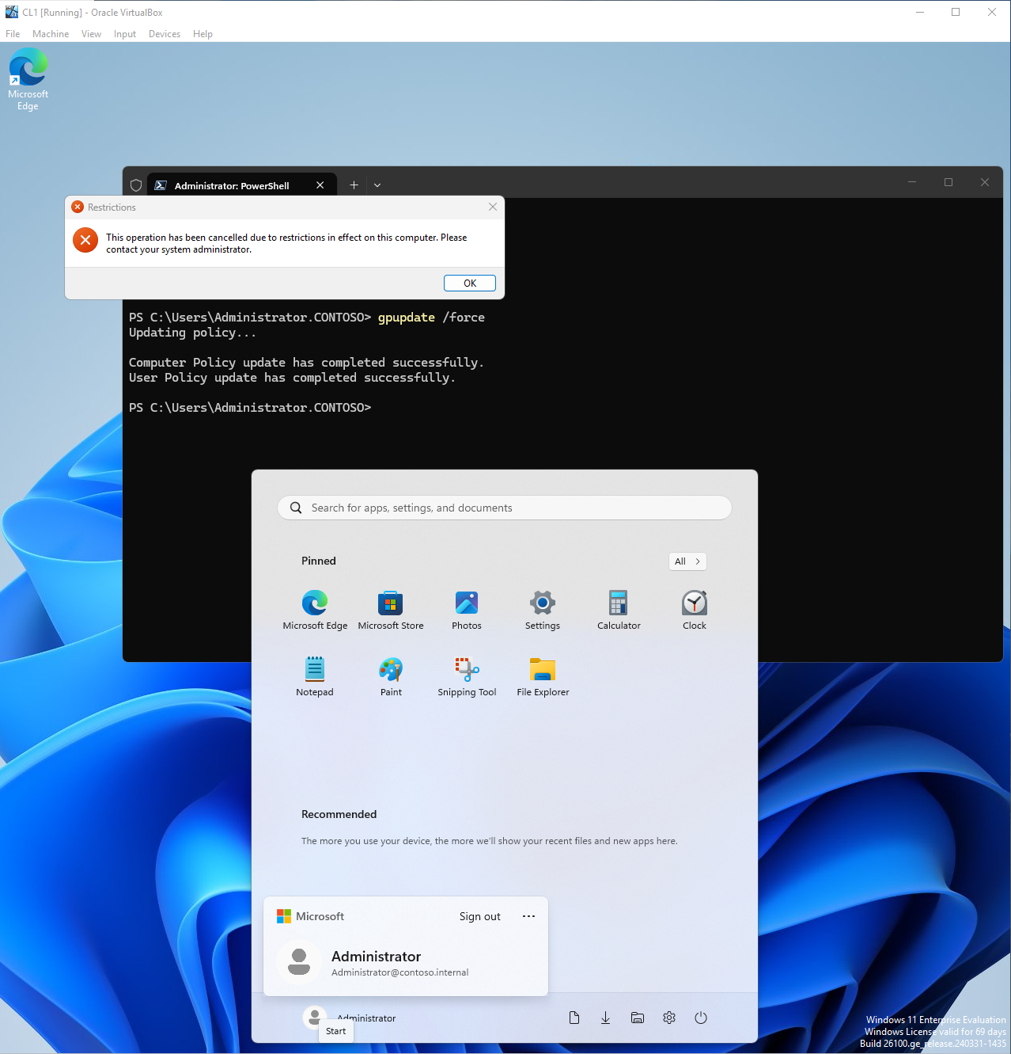

2.4: Filtering by Security Groups:



2.5: Filtering Using Permissions:


2.5.3
Method | Security Filtering (2.4) | Permission Deny (2.5)
How it works | Only listed groups receive the GPO | Listed group is explicitly denied the GPO
Best for | Targeting a GPO to specific groups | Excluding one group from an otherwise broad GPO
Risk | Easy to accidentally miss groups | Deny always overrides Allow - use carefully
Use case | "Apply only to Marketing" | "Apply to everyone except Admins"

